**Assignment 2**



**Spring 2025**

**CSE-408 Digital Image Processing**

Submitted by:

Registration No.:

Class Section: **C**

Submitted to:

**Engr. Mehran Ahmad**

Date:

**20th May 2025**

**Department of Computer Systems Engineering**

**University of Engineering and Technology, Peshawar**

**Activity 1:**

Write a MATLAB/Python script to perform piecewise linear contrast stretching.

**Code:**

**Output:**

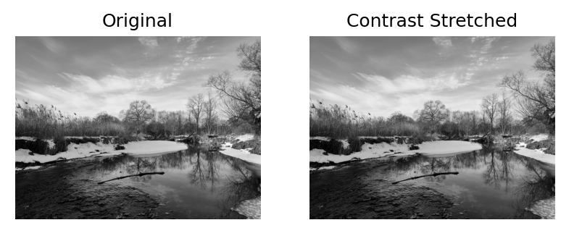

**Activity 2:**

Take an input image and implement gray-level slicing in MATLAB/Python.

**Code:**

**Output:**

**Activity 3:**

Implement bit-plane slicing in MATLAB and extract all 8 bit planes. **Show the code and the output result** (original image and bit planes from MSB to LSB).

**Code:**

**Output:**

**Activity 4:**

**Part A – Smoothing Filters (Noise Reduction & Background Enhancement)**

Select an image of your choice and investigate hidden or obscured objects in the background using the following smoothing techniques:

* + **Smoothing Spatial Filtering** (e.g., 3×3 Moving Average Filter)
  + **Order-Statistic Nonlinear Filters** o Median Filter o Min Filter o Max Filter

**Code:**

**Output:**

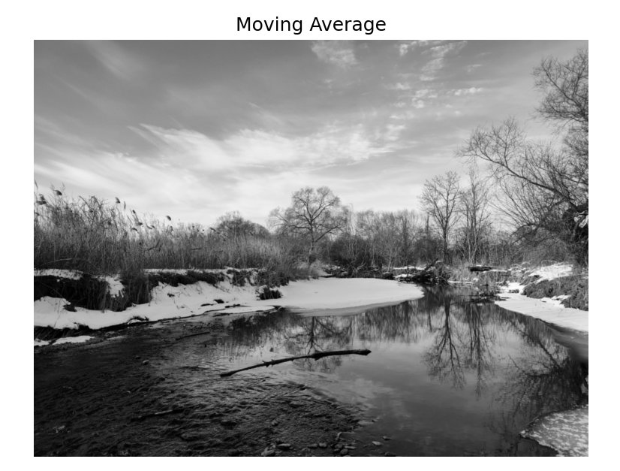

**Part B – Sharpening Filter (Detail Enhancement & Edge Detection)**

Use the same image to enhance important visual features (e.g., edges, textures, fine details) using the following sharpening technique:

* + **Laplacian Filter**

**Code:**

**Output:**

